**DAILY ONLINE ACTIVITIES SUMMARY**

|  |  |  |  |  |  |  |  |  |
| --- | --- | --- | --- | --- | --- | --- | --- | --- |
| **Date:** | **05/06/2020** | | | | | **Name:** | **PRANEETA P HANDRAL** | |
| **Sem & Sec** | **4thSEM. & ‘B’ SEC.** | | | | | **USN:** | **4AL19CS401** | |
| **Online Test Summary** | | | | | | | | |
| **Subject** | |  | | | | | | |
| **Max. Marks** | | **30** | | **Score** | | |  | |
| **Certification Course Summary** | | | | | | | | |
| **Course** | **Java Programming** | | | | | | | |
| **Certificate Provider** | | | **Greatlearning Academy** | | **Duration** | | | **3.5 Hrs.** |
| **Coding Challenges** | | | | | | | | |
| **Problem Statement:** Write a Java Program to find the duplicate characters in a string. | | | | | | | | |
| **Status: Executed.** | | | | | | | | |
| **Uploaded the report in Github** | | | | | **Yes** | | | |
| **If yes Repository name** | | | | | **LockdownCoding** | | | |
| **Uploaded the report in slack** | | | | | **Yes** | | | |

**Online Certification Course Summary**: I have taken my Online Certification Course in Greatlearning academy the course which I have opted is Java Programming. Course contains videos, tutorials, assessments and quiz. Today I have learn about What is java, install java & java IDE and First java program, variables and data types and also execute the some of the basic function programs . installation. I learned step by step procedure to install eclipse on my system.

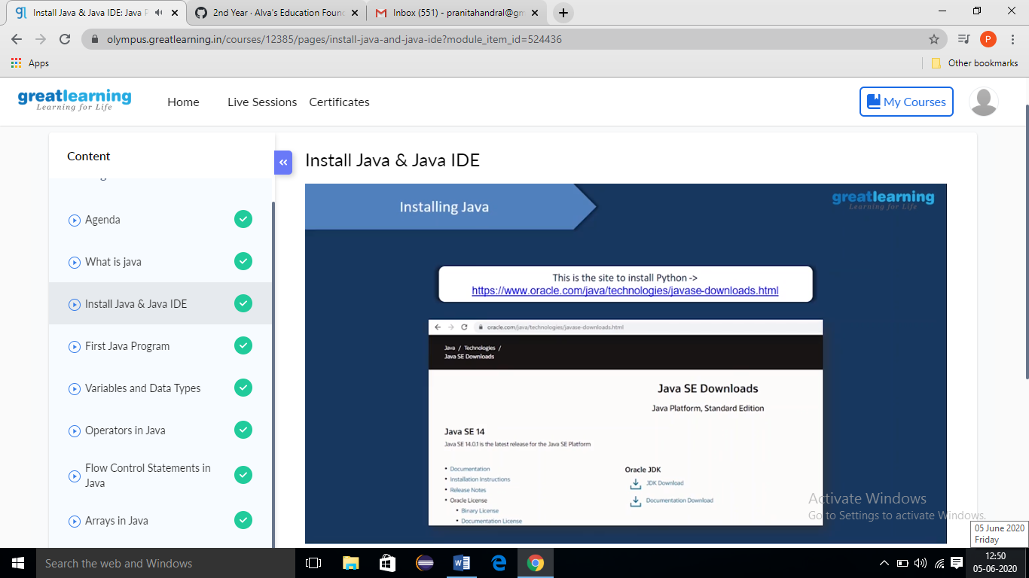

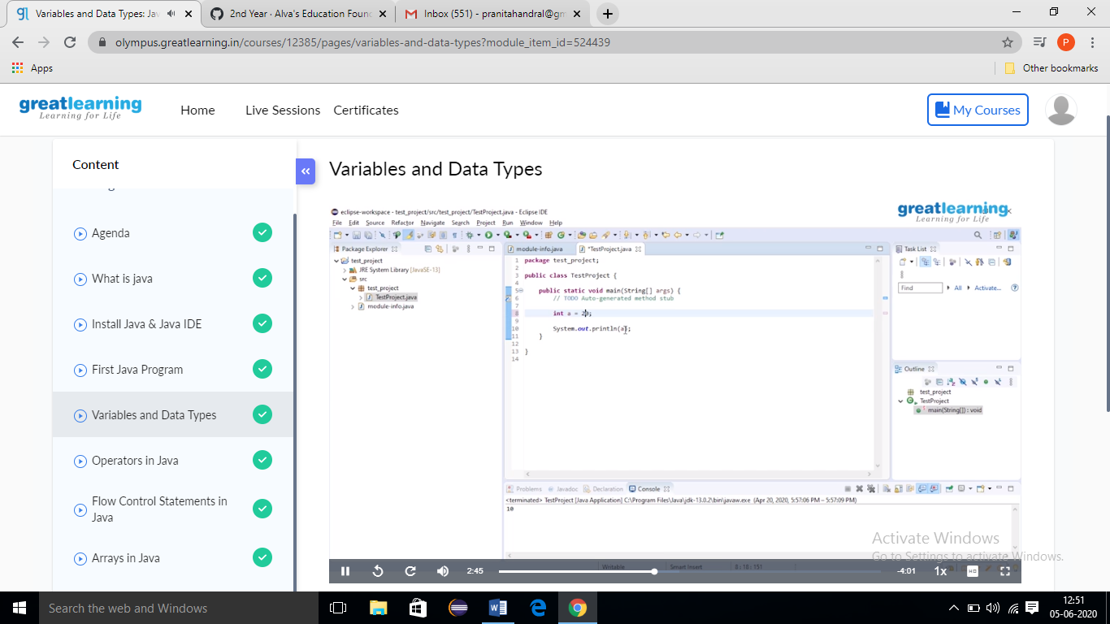

**Online Coding Summary: Today I received one program from Prof.** **Reena lobo CSE Dept. The program is mentioned above. to my GitHub repository and I’ve shared the snapshot below.**

